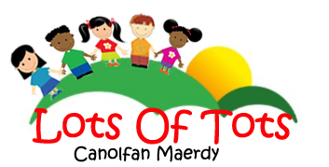

Parent
Pack

Statement of Purpose

for

Lots of Tots
Canolfan Maerdy
New Road
Tairgwaith
Ammanford
SA18 1UP

Contact details:

Lots of Tots: Office Telephone Landline: 01269 826283
Mobile: 07935 401199
Email: lotsoftots@canolfanmaerdy.co.uk

Canolfan Maerdy: Office Telephone Landline: 01269 826893
Email: admin@canolfanmaerdy.co.uk

Responsible Individual: Len Preece:
Tel: 01269 826893
Email: LJP@canolfanmaerdy.co.uk

Person in Charge: Mrs Anna Rowlands (Nursery Manager)
Tel: 01269 826283
Email: lotsoftots@canolfanmaerdy.co.uk

Named Deputies: Ms Emily Stewart (Deputy Manager)
Ms Caroline Howells (Deputy Manager)
Tel: 01269 826283
Email: lotsoftots@canolfanmaerdy.co.uk

Aims:

- To provide affordable, accessible, quality childcare and education
- To provide high quality day care for pre-school children in a safe and stimulating environment, that will allow each child to learn, play and grow to their full potential
- To work in partnership with parents/carers and to encourage them to become involved in the day to day activities of the Nursery
- To ensure the health and wellbeing of all the children and actively promote the concept of health and wellbeing to parents
- To meet children’s needs as individuals and within groups

Care Capacity

Lots of Tots cares for a maximum of 52 children (boys and/or girls) at any given time.

12 x 0 – 2 year olds: staffing ratio - 3 to 1 adult (minimum of 2)

16 x 2 – 3 year olds: staffing ratio - 4 to 1 adult (minimum of 2)
}
6 x 3 – 5 year olds:
staffing ratio - 8 to 1 adult (minimum of 2)
18 x 5 – 11 year olds:

Lots of Tots is also a Flying Start setting for the local authority for 2 - 3 year olds, operates a breakfast club and both after school and holiday clubs for 5 - 11 year olds.

Starting in the provision:

Lots of Tots acknowledges the importance of parents/carers and staff working together to help children settle in the provision and develop confidence to participate in all the activities offered. Some children take longer than others to settle. The treatment of each child as an individual is our main concern. Parents/carers are encouraged to use our ‘settling-in’ service to help with their child’s transition to our care; they may stay for the whole or part of the session, depending on the needs of the child (please refer to the Admissions Policy).

There is a wrap-around service for children attending ½ day school sessions. The nursery's 7-seater, fully insured people carriers are used to convey children to and from their school.

The nursery is open between the hours of 0730hrs and 1800hrs, Monday to Friday.

The nursery is closed on weekends, bank holidays and the period between Christmas and New Year.

The setting has separate rooms for each of the age groups as well as a sleep/rest room for the babies, all at ground floor level.

Appropriate equipment, toys, books, games and learning materials are provided for all children.

There is a large outdoor play area which contains among other things, a large wooden play house, raised garden beds and a mud kitchen.

Staff:

Staff are highly qualified and experienced within the Early Years Sector and Lots of Tots actively supports them with their continuous professional development. We welcome students on placement, volunteers and visitors who enrich the experiences of children. Each will have enhanced DBS checks and first aid certificates and will implement all the Nursery Policies and Procedures, ensuring that children’s safety and wellbeing are paramount at all times.

Meals:

We provide a two course lunch and menus are regularly rotated and re-designed. Fresh, healthy, varied and well balanced meals are prepared daily in the kitchen by our dedicated, qualified cook. All our staff hold an up-to-date level 2 Food Hygiene certificate. Fruit and vegetables are bought locally and only high quality meat and fish are used. Snacks are served at approximately 10.00 am and 2.00 pm, lunch at 12 midday, tea at 4.00 pm and drinks are available throughout the day. Every effort is made to meet any special dietary and/or cultural requirements.

Areas of Learning:

Lots of Tots follows the Foundation Phase, which is based on the principle that early years' provision should offer a sound foundation for future learning through a developmentally appropriate curriculum.

The Framework for Children’s Learning for 3 to 7 year-olds in Wales sets out the seven Areas of Learning, outlining what a child should be taught and their expected outcomes.

- Personal and Social Development, Well-being and Cultural Diversity
- Language, Literacy and Communication Skills
- Mathematical Development
- Knowledge and Understanding of the World
- Physical Development
- Creative Development
- Welsh Language Development

Key Workers:

A dedicated member of staff is assigned to each child, giving them the reassurance to feel safe and cared for and building relationships with parents. When children are happy and feel secure they feel confident to explore and try new things. A key worker will:

- Help your child to become familiar with the setting and feel confident and safe within it;
- Develop a genuine bond with the child and offer a settled, close relationship;
- Meet the needs of the child in their care and respond to their feelings, ideas and behaviour;
- Talk to parents to make sure the child is being cared for appropriately for each family and value that family;
- Make regular observations, take photographs of a child’s learning, monitor progress and intervene if there is an area of development which needs supporting.

Please see Lots of Tots’ Key Worker Policy within this pack for full details.

Language:

The setting is fully bilingual and Welsh is the main language of communication/administration. Welsh is introduced to all the babies/children through the use of greetings, songs, stories, games and other learning activities. All of our staff are fluent Welsh/English speakers and provision can be tailored to suit individual needs.

Activities:

Lots of Tots provides a wide range of equipment and educational toys. There are areas for ‘messy play’ that will include water, sand, play dough and painting. Activities are planned to suit children’s ages and individual needs. The Nursery provides adult-led and child-led experiences that are planned termly, weekly and daily, in advance, using themes based on the seven areas of learning in the Foundation Phase.

Activities are risk assessed and children are encouraged to contribute to any review or evaluation of their experiences as they are able and willing.

A sample of a typical day’s routine for the baby unit is:
8.00 - 9.10 am | Free play and settling in
9.10 - 9.30 am | Circle time - songs and stories
9.30 - 10.00 am | Play time
10.00 - 10.30 am | Snack time
10.30 - 11.30 am | Table top activities including sensory play
11.30 - 12.00 pm | Circle time - songs and stories
12.00 - 12.30 pm | Lunch time
12.30 - 2.00 pm | Table top activities including sensory play
2.00 - 2.30 pm | Snack time
2.30 - 3.00 pm | Table top activities including sensory play
3.00 - 3.30 pm | Circle time - songs and stories
3.30 - 4.00 pm | Tea time
4.00 - 6.00 pm | Free play and collection of children

Circle time is tailored to suit the age range of the children. Singing nursery rhymes with actions will encourage young children to focus and interact, even though their language skills are still developing. Very young babies may not sit for a story; however “touch and feel” books and large picture books can keep the children interested.

Please note that routines remain flexible in order to accommodate children’s varying individual needs. Children’s nappies are checked regularly throughout the day by their key worker and periods of rest and feed times always reflect the needs of the child and the wishes of the parents.

A sample of a typical day’s routine for the toddlers is:

8.00 – 9.30 am | Free play and settling in
9.30 - 10.00 am | Snack time
10.00 - 11.00 am | Topic based activities including art and craft, sensory play, language and numeracy areas
11.00 - 11.15 am | Outside play
11.15 - 12.00 pm | Circle time
12.00 - 1.00 pm | Lunch time
1.00 - 2.00 pm | Story time and free play
2.00 - 2.30 pm | Snack time
2.30 - 4.00 pm | Outside play
4.00 - 4.30 pm | Snack time
4.30 - 6.00 pm | Free play and collection

Parental involvement:

The lasting benefit of parental involvement in a child's development and pre-school education is now clearly supported by academic research, as well as providing a lot of pleasure for parents/carers and their children. Lots of Tots considers that parents are the prime carers and educators of their children and as such, will be encouraged to be involved in all aspects of the provision. Please see Parental Involvement Policy and Procedure/Partnership Agreement.

Policies and Procedures:

Lots of Tots has produced a comprehensive range of policies and procedures that include arrangements for dealing with routine operational practice, complaints, concerns, and any emergency that may occur during operational hours. They are designed to ensure effective and safe management of our service and to offer the best possible environment and experience for the children and families who use it.

The policies and procedures are developed and maintained in line with and/or exceed National Minimum Standards and Regulations. They are reviewed regularly (at least annually) and updated (and CIW informed of any changes) as necessary.

A full list of the policies and procedures adopted by the Nursery is included in the Admissions Pack and posted on the website. Some key policies are included within this Parents’ Registration Pack. A file containing the full policies and procedures is available at Nursery reception for all who wish to view.

Fees: (see also Admissions Policy)

All meals are included in childcare charges. Fresh drinking water is available to the children throughout the day.

Fees are payable every four weeks, in advance, by Cheque, Cash or Standing Order/Direct Debit.

Fees are payable if a child is absent without notice or for a short period of sickness/family holiday.

Parents/carers are advised to speak to the Nursery Manager about payment of fees in cases of prolonged absence.

We also accept Child Care Vouchers allowing working parents to benefit from reduced tax and N.I. on a substantial portion of day care fees. Please speak to the Nursery Manager for further details.

The Nursery reserves the right to withdraw a place for a child if the payment of two invoices is left outstanding.

Observations, Assessment and Record Keeping:

Lots of Tots staff take a reflective approach to their work, using observation as a tool to plan activities and ensure children’s needs are met. The progress of children is assessed by observation and recorded. The Nursery has a duty to share some information with the Local Authority, Care Inspectorate Wales (CIW) and in the case of the Child Development Assessment Profile, the Welsh Government. Our records are kept in line with GDPR requirements and our Confidentiality Policy and are available for discussion with parents/carers at any time.

Complaints and Concerns:

A complaint can be made by or on behalf of relevant children about the service they are receiving at the Nursery.

If any parent/carer should have cause for complaint they should in the first instance take it up with the managers, Anna Rowlands, at the nursery, or in their absence Emily Stewart or Caroline Howells the Deputy Managers. We will record the details on our complaints form or you may ask for a complaints form.

If your complaint is with either of the managers, you can complain to Len Preece, the Registered Individual for the Nursery facility.

If the matter cannot be resolved to your satisfaction, then you have the right to raise the matter with our registering and inspecting body, CIW. You may go straight to them if you feel the matter requires this:

Care Inspectorate Wales
Government Buildings
Picton Terrace
Carmarthen SA31 3BT
Phone: 0300 7900 126
Email: ciw@wales.gsi.gov.uk
Website: ciw.org.uk

Following a complaint, Lots of Tots / Canolfan Maerdy will endeavour to resolve the matter in house, within 14 days. This can be extended for up to a further 14 days with the agreement of the complainant. Lots of Tots / Canolfan Maerdy must confirm in writing to the complainant the agreed resolution. If the complaint is unable to be resolved by Lots of Tots / Canolfan Maerdy, the complainant can contact the registering body. Lots of Tots / Canolfan Maerdy must, at the request of the registering body or any local authority which has arranged for the provision of day care for a relevant child, confirm the local resolution of a complaint.

The welfare of the child must be safeguarded and promoted and account must be taken of the ascertainable wishes and feelings of the child. Once a complaint has been made Lots of Tots / Canolfan Maerdy must inform the complainant of their right to complain to the registering body or the local authority which has arranged for the provision of day care.

Lots of Tots / Canolfan Maerdy must inform the complainant of any advocacy services which may be of assistance to the complainant. Lots of Tots / Canolfan Maerdy must inform the complainant that a local authority receiving a complaint must provide information and assistance for complainants and must in particular offer help in obtaining an advocate.

Lots of Tots / Canolfan Maerdy, with the agreement of the complainant, can make arrangements for conciliation, mediation or other assistance for the purposes of resolving the complaint.

Lots of Tots / Canolfan Maerdy must keep a written record of any complaint, the outcome of the investigation and any action taken in response.

The Registered Individual must supply to the appropriate office of the National Assembly at its request a statement containing a summary of the complaints made during the preceding twelve months and the action taken in response to each complaint.

Complaints are dealt with by way of formal consideration must be resolved as soon as practicable and in any event within 35 working days of the request for formal consideration. This time limit may be extended with the agreement of the complainant. If the complaint has not been resolved within the 35 days then Lots of Tots / Canolfan Maerdy will inform the registering body the reasons for the delay. The outcome of a formal consideration must be confirmed in writing by Lots of Tots / Canolfan Maerdy to the complainant and must summarise the nature and substance of the complaint, the conclusions and the action to be taken. A copy of this will be sent to the registering body and the local authority which has arranged for the provision of day care for a relevant child.

Lots of Tots welcomes suggestions and constructive criticism from parents/carers and children to help us maintain a high quality provision. Please speak with the Nursery Manager if you would like to make any suggestions. A suggestion box is also available at reception. However, from time to time a parent/carer or child may find it necessary to follow the Complaints Policy and Procedures, copies of which can be found in the Admissions Pack. Alternatively, the parent/guardian can contact:

- the nursery managers, the named deputy or the responsible individual, in person or by telephone.(details at the beginning of this statement of purpose)
- CIW on 0300 7900 126
- www.ciw.org.uk

Arrangements for Dealing with an Emergency:

Lots of Tots has comprehensive Emergency Procedures. Details can be found within the Admissions Pack or can be obtained from the Nursery Manager.

Terms and Conditions:

These are set out in the Contract between Parents/Carers and Lots of Tots and are implicit within our Policies and Procedures.

The Contract must be signed and the Registration Form completed by parents/carers before their child attends.

Copies of the Contract, Registration Form and the full set of Policies and Procedures are available from Lots of Tots.

CIW and parents/carers will be informed of any changes to the Statement of Purpose which is reviewed at least annually or as a result of a change in operational practice.

NURSERY REGISTRATION PACK
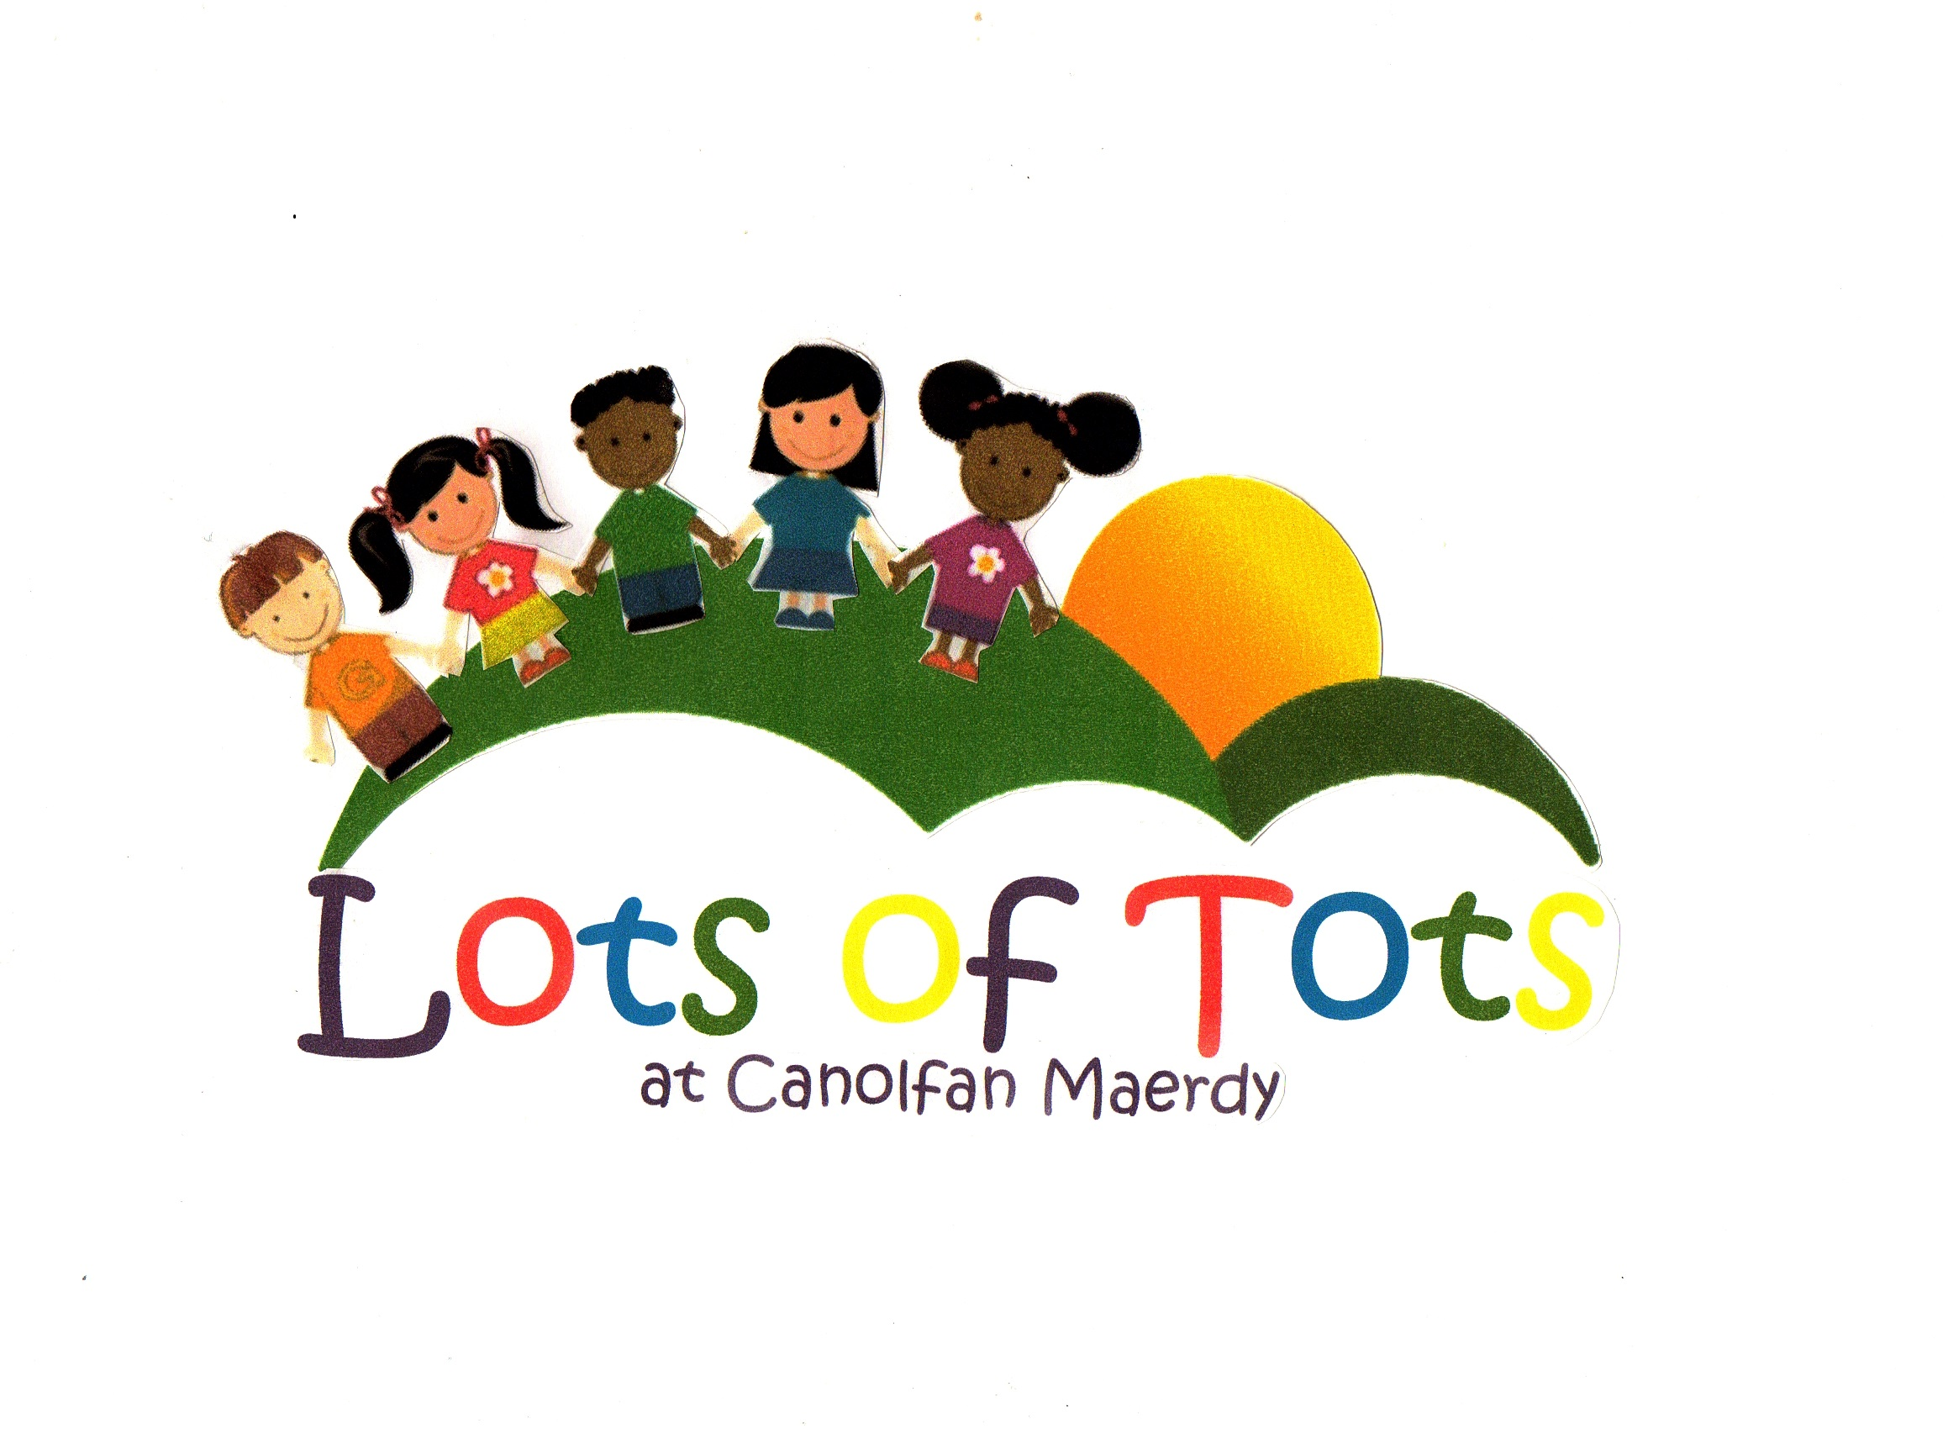

Child’s Details:
Child’s Full Name:
Known As: |  |  | Male/Female:
Date of Birth: |  |  | Age:
Nationality: |  |  | First Language:
Address: |  | Post Code:
Home Tel No:
Parent/Guardian Details:
Name of Person(s) holding parental responsibility:
Mother’s/Carer’s Name:
Address (if different to child): |  | Post Code:
Work Address: |  | Post Code:
Occupation: |  |  | Work Tel No:
Mobile No: |  |  | Email Address:
Father’s/Carer’s Name:
Address (if different to child): |  | Post Code:
Work Address: |  | Post Code:
Occupation: |  |  | Work Tel No:
Mobile No: |  |  | Email Address:
Alternative Contacts:
Who may collect your child or be telephoned in an emergency
(must be minimum of 18 years of age)
1. | Name: |  | Tel No:
 | Address: | Post Code:
 | Relationship to Child:
2. | Name: |  | Tel No:
 | Address: | Post Code:
 | Relationship to Child:
3. | Name: |  | Tel No:
 | Address: | Post Code:
 | Relationship to Child:
4. | Name: |  | Tel No:
 | Address: | Post Code:
 | Relationship to Child:
I hereby confirm that I wish the following person(s)
to have restricted contact with my child as follows:
………………………………………………………………………………………………………….
………………………………………………………………………………………………………….
………………………………………………………………………………………………………….
………………………………………………………………………………………………………….
………………………………………………………………………………………………………….
NOTE: Every effort will be made to comply with the above request
but it cannot be guaranteed because of the confines of the law.

Medical Information:
The information below
may be used in the event of an emergency, or hospital treatment.
Child’s Doctor’s Name:
Name of GP Surgery:
Address: | Post Code:
Tel:
Child’s Health Visitor – Name:
Address: | Post Code:
Tel:
Immunisation Record:  (Please tick box if child has received vaccination): | Diptheria, Tetanus, Whooping cough
 | Poliomyelitis
 | Meningitis C
 | Hib
 | Measles, Mumps, Rubella
 | Pneumococcal conjugate vaccine (PCV)
Does your child have any medical conditions?
(If so, please list)
Are you aware of any allergies your child may have?
(If so, please list)
Are you aware of any food allergies / intolerances your child may have?
(If so, please list}
Please provide full details of any foods your child does not eat on religious or other grounds:
Does your child have any special needs or requirements?
(If so, please list)
Are there any emergency medical procedures that are prohibited for family, cultural or religious reasons?
(If so, please list)

Hours and days required: (please tick) | Mon | Tue | Wed | Thu | Fri
Full day 7.30am–6pm
Half day am 7.30am-1pm
Half day pm 1pm-6pm
9am – 3pm session
Over 2’s 2 hour session 9-11am
Over 2’s session 1-3pm
3+ Wrap around 7.30am-1pm (includes school runs - term time only contracts)
3+ Wrap around 11.30am-3.30pm (includes school runs; term time only contracts)
3+ wrap around 11.30am-6.00pm (term time only contracts)
After school club 3 – 6pm (includes school runs)
Breakfast club 7.30am - school (includes school runs)
Holiday club 5+ full day 7.30-6pm
Holiday Club 5+ half day 9am-3pm
Holiday club 5+ half day 7.30am-1pm / 1-6pm

Start date required: …………………………………………………..…..
Where did you hear about the nursery? …………………………………………………..…..

- Please note there is a £32.50 registration fee to register at the nursery. (Non-refundable)

- A deposit for four weeks’ planned childcare is also required at the time of registration.

- A period of one month’s notice in writing is required from parents/carers to end a child’s term at nursery.

- Fees must be paid by the 28th of the following month to which the issued invoice/ statement relates.

- Fees will be invoiced to the person(s) named on the registration form. Please note: your child’s place may be suspended/withdrawn if you do not keep up to date with payments.

- As we still have to cover staff salaries, fees are payable during absence due to sickness or holidays. (Please note that the nursery is closed for bank holidays and between Christmas and New Year and there is no charge for these closures.)

- Fees will be chargeable if the nursery needs to close due to unforeseeable circumstances (eg contagious illnesses, weather conditions or damage to the premises.)

- The Nursery Policies and Procedures are on display in the reception area and your attention is drawn to them.

- There will be a charge of £7 for early drop off or late collection of children if this exceeds 15 minutes of their contracted session.

- Additional charges apply for pick/up drop offs, snacks and meals for those on the 30hr scheme. (Please see Price List.)

- Additional charges apply for meals where children stay additional hour(s)

Signed: ………………………………………………. Date: …………………………….……………

Initial application date received |  | Waiting
Registration fee received / method of payment / date |  | Confirmed

LOTS OF TOTS AGREEMENT FOR PAYMENT OF FEES
Child’s full name: |  | Date of Birth:
Parent(s)/Carer’s Names:
Person responsible for payment of fees:
Full Name: |  | Relationship to Child:
Address:
 |  | Postcode:
Email Address:
Telephone: | Day
 | Evening
 | Mobile

The hours and days of attendance will be: (please tick)
 | Mon | Tue | Wed | Thu | Fri
Full day 7.30am–6pm
Half day am 7.30am-1pm
Half day pm 1pm-6pm
9am – 3pm session
Over 2’s 2 hour session 9-11am
Over 2’s session 1-3pm
3+ Wrap around 7.30am-1pm (includes school runs - term time only contracts)
3+ Wrap around 11.30am-3.30pm (includes school runs; term time only contracts)
3+ wrap around 11.30am-6.00pm (term time only contracts)
After school club 3 – 6pm (includes school runs)
Breakfast club 7.30am (includes school runs)
Holiday club 5+ full day 7.30-6pm
Holiday Club 5+ half day 9am-3pm
Holiday club half day 7.30am-1pm / 1-6pm

The current fee for your child based on the above requirements will be £ ……………….……… per four week month.

NB: Four week’s written notice period is required to change these, subject to space being available or if you wish to withdraw your child from the nursery.

Preferred payment method: (please indicate)
Cash
Standing Order
BACS
Nursery Vouchers

Frequency of payment: (please indicate)
Weekly
Monthly

When paying by standing order, childcare vouchers, BACS or online banking,
ensure you use child’s full name AND nursery name as payment reference.

Payment Terms:

- Accounts must be paid by the 28th of the following month from the month date of the statement.

- A late payment fee of £20 will apply and/or 2.5% will be added to overdue accounts as per the terms and conditions of your contract.

- Your child’s place will be suspended / withdrawn if you do not keep up to date with payments.

- Please note that fees are payable during periods of absence from the nursery due to sickness

I hereby agree to pay the fees as stated in the above payment terms.

Signed: ______________________________________ Date: ________________________

LOTS OF TOTS CONSENT FORMS

Child’s full name……………………………………………………….DOB………………….…………

1. | PERMISSION FOR PHOTOGRAPHY (*delete as appropriate)
I* / We* give* / do not give* consent for my* / our* child ………………………………….

To be photographed at nursery and for these to be used for (please tick as appropriate):
 | Display purposes and development books within the nursery
 | External marketing events
 | Lots of Tots / Canolfan Maerdy Website
 | Lots of Tots / Canolfan Maerdy Social Media i.e. Facebook and Twitter
 | Signed (parent/carer) .……………………………………………..……………………………

2. | PERMISSION FOR OUTINGS (*delete as appropriate)
I* / We* give* / do not give* consent for my* / our* child ………………………………….

To be taken on local outings. Permission for outings involving transport will be sought on each occasion.
 | Signed (parent/carer) .……………………………………………..……………………………

3. | PERMISSION FOR ADMINISTRATION OF SUNCREAM (*delete as appropriate)
I* / We* give* / do not give* consent for my* / our* child ………………………………….

To receive administration of sun cream during nursery hours when considered appropriate by nursery staff.
 | Signed (parent/carer) .……………………………………………..……………………………

4. | EMERGENCY MEDICAL MEDICATION / TREATMENT (*delete as appropriate)
In the event of not being contactable, I* / We* give* / do not give* my* / our* consent to
my* / our* child ………………………………………………………………………………
receiving any emergency medical treatment, which is necessary.
 | Signed (parent/carer) .……………………………………………..……………………………

5. | CHILD PROTECTION / SAFEGUARDING (*delete as appropriate)
 | I*/We* understand that any carer who suspects that a child in his/her care may have been abused or neglected, has a duty to report this to social services.
 | Signed (parent/carer) .……………………………………………..……………………………
LOTS OF TOTS TERMS AND CONDITIONS

This contract is between Lots of Tots Day Nursery and _____________________________
concerning the care of _________________________ who will be attending Lots of Tots Day Nursery.

We want the children in our care to be safe, happy and well cared for, and for you as parents to be satisfied with the service we provide. We believe that this is best achieved with good communication between the nursery and yourselves. This contract sets out what you can expect from us and what we can expect from you in order to maintain our high standards. The nursery also has a comprehensive set of policies and procedures which form part of this contract. These are available for inspection at any time and you are strongly advised to read them. The terms of this contract will run for the entire duration of your child’s stay at the nursery.

Opening Times
Our opening times are 7.30 am – 6.00 pm, Monday to Friday, throughout the year except for Bank Holidays and the period between Christmas and New Year.

Morning sessions are 7.30 am – 1.00 pm and afternoon sessions are 1.00 pm – 6.00 pm. Attendance that ‘crosses’ over the threshold will be charged at an hourly rate.

Please note that children may attend for a maximum period of 10 hours per day.

We will try to accommodate any requests you may make for any additional sessions and/or extended hours of childcare at the nursery, whenever possible we ask if you could inform the nursery by 1pm on the Thursday for amendments to the following week.

Collection
Parents/carers are asked to provide the names and contact details of a minimum of two persons over the age of 18 authorised to collect your child. If there should be any temporary alteration to these arrangements you must let us know in advance and give adequate information about the person who will be coming to the nursery, we will require proof of identity or a password. Please note that we will not let your child leave nursery with anyone who we have not been informed about.

Immediately inform us if you are unable to collect your child by the official collection time. An early drop off/late collection charge of £7 for each surplus 15 minutes period will be applied. If this is after 6pm, an extra £20 charge will be incurred. Parents /carers should be aware that CIW regulations require the nursery to be vacated by the designated closing time – ie 6 pm.

Please inform us if your child is the subject of a court order and provide us with a copy of such order on request.

Health and Illness
Please do not bring your child to nursery if he/she is unwell. The nursery reserves the right to refuse entry to or send home any child who appears unwell or is suffering from a contagious or infectious complaint. If your child should become ill while at nursery we will contact you or a person nominated on your admission form to collect him/her.

To ensure that we can contact you speedily, please ensure that all contact details are kept up to date. You are also asked to inform us if your child has contracted a contagious illness as we may be able to minimise the spread of such diseases if kept informed.

Guidelines for the exclusion periods of illness which are set by the Local Health Protection Team, can be found in your parent pack and in the nursery reception.

Any child who has been sent home from nursery because of ill health will not be re-admitted for at least 24 hours. If a child is prescribed antibiotics they will not be allowed to return to the nursery for 48 hours.

Please notify one of the Nursery Managers / Deputy Manager if your child is absent from the nursery due to sickness, they will not be allowed to return to the nursery for a period of 48 hours from the last episode of vomiting / diarrhoea.

Medication
Prescribed medication or ‘over the counter’ remedies may be administered in nursery with prior written consent. It is your responsibility to notify the Manager or Key Worker and to sign the necessary form.

Prescribed medication must be clearly labelled with child’s full name. Medicines should be handed to the keyworker on its arrival in its original packaging.

If a child has a slightly raised temperature but is otherwise well, we will contact you for permission to administer Calpol.

Dietary needs
We ask parents to inform us and keep us up to date on any dietary requirements that their child may have as diagnosed by a doctor or dietician. This will be recorded on their personal file and kitchen staff will have responsibility to provide suitable alternatives.

Menus will be displayed for inspection, and parents and children will be able to feed into the review of these. An example menu is also included in the parent pack.

Outings
Parents/carers will be informed of any planned outings and written consent will be required before a child is allowed to participate. You will also be invited to give your consent for your child to be allowed to go on short walks as part of the nursery activities. No child is allowed to leave the nursery during his/her contracted hours without this written permission.

Photography
Parents/carers should be aware that the nursery occasionally takes photographs within the nursery, which may be used for display purposes, the children’s development books and in training or promotional material. Parental preference is adhered to and permission will be sought via Lots of Tots consent forms which is completed at enrolment.

Behaviour
Lots of Tots encourages all children to respect other children, staff and nursery property using approaches appropriate to their development stages. We ask you to encourage your child to abide by nursery behaviour guidelines and accept our behaviour management policy, copies of which are available in the parent pack and nursery reception.

Equal Opportunities
Nursery staff will implement a policy of equal opportunities. We aim to develop respect and have tolerance for others regardless of race, religion or gender. Parents and children are required to adhere to the nursery equal opportunities policy, a copy of which is available in the office.

Safeguarding Children
It is understood that the nursery is under an obligation to report to the relevant authorities any incident where we consider a child may have been abused or neglected. This may be done without informing the parent/carer.
Any information given by a parent regarding their child will be treated with the utmost confidentiality, except in cases where abuse towards a child is suspected. The divulging of confidential information relating to the nursery, its employees or customers to any third party is considered a breach of confidence and as such is regarded as gross misconduct which could lead to summary dismissal from employment or cancellation of a nursery place.

Fees and Payment
You will be required to pay a registration fee of £32.50 for each child new to using the nursery together with a deposit equivalent to the monthly contracted fees for your child/ren. You will then be billed calendar monthly in retrospect for all monthly nursery fees incurred.

All parent(s)/ carers are required to identify the way in which they would like to pay their nursery invoice and this is requested information on the agreement for payment of fees form.
Payments can be made by cash, child care vouchers (please ensure the nursery is registered with the voucher company), cheque or BACS. Should you wish to pay via BACS or set up a standing order our account details are as follows:

Bank: CAF Bank Sort Code: 40-52-40 Account Number: 00030459

Please note it is the responsibility of the parent/carer to set up a standing order arrangement on time with their bank, if this method is preferred. Please use your child’s full name and nursery as a reference with the bank. It is recommended that if you choose to pay by standing order that you check to confirm the first payment has been paid on time by the bank in case there has been a delay in processing.

We ask that you settle your account promptly to help us keep costs down and to avoid you incurring late payment charges. Fees are payable by the 28th of each month following that to which they relate. Late payment fees will generate a late payment fee of £20 for each calendar month monies are owed. It is your responsibility to obtain a receipt from the nursery manager / deputy manager / finance office as proof of payment.

Fees will be subject to an annual increase on notice from Lots of Tots Day Nursery and Canolfan Maerdy. Prices quoted are per child for a core day and include all meals, snacks and drinks. Extra hours will be charged at the ruling rate and must be booked in advance and will be invoiced in arrears.

If you have a query with your nursery invoice, please advise nursery management within 7 days of receipt of the invoice otherwise late payment charges may be incurred.

Please note that fees are payable during periods of absence from the nursery due to sickness or any holidays you wish to take, excluding bank holidays and the period between Christmas and New Year when the nursery is closed. This rule is necessary so that the nursery can properly budget for its own expenditure and to ensure the cost of individual default does not fall on other parents. No compensation will be paid or refund given if the nursery has to be closed due to any reason beyond the control of the nursery, such as power failures, infectious diseases, premises damage or weather conditions.

Once a place at the nursery has been confirmed, the first month’s fees become payable as a deposit to secure the place. Please provide us with at least 1 months’ notice of your intention to decrease the number of hours your child spends at the nursery or to withdraw your child from nursery and end this agreement. If insufficient notice is given you will be responsible for the full fees for your child for 1 month from the date of any changes as if their hours had not decreased. If you are ending this agreement, notice must be given by completing our Exit Procedure form, which can be obtained from the Nursery Manager.

Unpaid fees
The nursery reserves the right to charge interest on late fees at the rate of 2.5% in addition to the monthly late payment fee of £20 if outstanding balances are not cleared within one calendar month. For dishonoured cheques/payments a charge of £20 per occasion will be applied. Your child’s space will be suspended / withdrawn from the nursery if fees remain outstanding more than 7 days beyond the due date and the registration terminated.

Disclosures
Parents must, as soon as possible, disclose to the nursery any known medical condition, health problem or allergy affecting the child, or any family circumstances or court order which might affect the child’s welfare or happiness, or any concerns about the child’s safety.

Data Protection
As part of the General Data Protection Register (GDPR), it is a legal requirement of the nursery to hold information about children using the nursery and its staff. Basic information is used for registers, invoices and for emergency contacts; however all records will be stored in a locked cabinet.

Concerns / Complaints
If you are unhappy with any aspect of the nursery then we have a complaints procedure to ensure that the matter is dealt with swiftly and appropriately. The person to whom you should speak are listed in the Complaints Procedure which is displayed in the nursery. If after following this procedure you are still not satisfied, you should contact Care Inspectorate Wales at WW Regional Office, Government Buildings, Picton Terrace, Carmarthen, SA31 2AF. Tel: 0300 790 0126

LEGAL CONTRACT
I / We agree to comply with the terms of the contract as set out above. I / We understand that the policies in force at the nursery at the present time also form part of the contract.

I / We understand that it is our responsibility to update the nursery with any changes to my / our child’s details, i.e. home address, emergency contact numbers, work contact numbers and so forth.

Signed: (both parents/carers to sign where applicable)

Parent/Carer 1 ………………………………………………… Date…………………………….……

Parent/Carer 2 ……………………………………………….... Date……………………………….…

Nursery Manager (print) ………………………………………………................................................

Signed …………………………….…………………………… Date…………………………………..

PLEASE RETURN COMPLETED, SIGNED PACK TO:

The Nursery Manager
Lots of Tots Nursery
Canolfan Maerdy
New Road
Tairgwaith
Nr Ammanford
SA18 1UP

Should you have any queries, please contact the Nursery as follows:
Tel: 01269 826283 (Office) 07935 401199 (Mobile)
Email: lotsoftots@canolfanmaerdy.co.uk
Website: www.canolfanmaerdy.co.uk

Out of Nursery Service Contract – Pick-ups/Drop-offs
Full Name of Child: |  | Date of Birth:
Address:
 |  | Post Code:
Name of Parent/Carer 1: |  | Contact Tel. No:
Name of Parent/Carer 2: |  | Contact Tel. No:
Medical Requirements/ Allergies:

Place of Collection/ Drop-off
Address of Collection/Drop-off
 |  |  |  |  |  |  | Contact Tel No.
Collection Times/ Days
 | Mon |  |  | Tue | Wed |  |  | Thu |  | Fri
Time:
Drop-off Times/ Days
 | Mon |  |  | Tue | Wed |  |  | Thu |  | Fri
Time:
Please give details of where your child is to be collected/dropped-off (eg which entrance/exit etc)
I give permission for my child to be transported in a vehicle/walked by a staff member employed by Canolfan Maerdy/Lots of Tots Nursery:
Print Name: |  |  |  |  |  | Sign:
Relationship to child: |  |  |  |  |  | Date:
ALL ABOUT ME (0-18 MONTHS)
Please answer these questions in as much detail as possible, this will help us to get to know your child better and help them to settle in quickly.
Child’s Name |  | Date of Birth
Nationality |  | Religion
First Language |  | Other Spoken Languages:
Are any milk feeds given during the day? |  | Yes No
If so, what are the usual times that milk feeds are given?
What type and quantity of milk does your child drink?
Does your child drink water and diluted fruit juices?
Are there any specific times that your child drinks water and diluted fruit juices?
Are you weaning your child? |  | Yes No
What consistency are they at?
What are your child’s favourite foods?
Are there any individual or cultural needs?
How do they like to be fed?
How does your child go to sleep?
What is their sleep pattern?
Do they have a comforter or special toy?
What type of nappies, wipes, creams do you use on your child?
Does your child have any siblings? What are their names and ages?
Are there any other special people?
What are their names and ages?
Are there any other special people or pets in your child’s life?
What are your child’s current skills/ interests?
How would you like these to be developed?
What are your child’s favourite toys, songs and games?
Is there anything else you feel we should know about your child?
Please tick for permission to apply the following: |  | Nappy Rash Cream  Sunscreen

ALL ABOUT ME (18 MONTHS+)
Please answer these questions in as much detail as possible, this will help us to get to know your child better and help them to settle in quickly.
Child’s Name |  | Date of Birth
Nationality |  | Religion
First Language |  | Other Spoken Languages:
What does your child know about their culture?
Are there any special times you celebrate?
What type of milk does your child drink?
Does your child drink water and diluted fruit juices?
What are your child’s favourite foods?
Are there any individual or cultural needs?
Are they able to feed themselves? |  | Yes No
What foods don’t they like?
Does your child have a nap during the day? |  | Yes No
Do they have a comforter or special toy?
What type of nappies, pull-ups, wipes, creams do you use on your child?
Or is your child toilet trained, or training?
Do they prefer to sit on a potty? |  | Yes No
Does your child have any siblings?
What are their names and ages?
Are there any other special people or pets in your child’s life?
Describe your child’s temperament
What does your child like to play with?
What are your child’s favourite songs, rhymes and games?
What are your child’s current skills and/or interests?
How would you like these to be developed?
Please tick for permission to apply the following:
Please tick for permission to apply the following: |  | Nappy Rash Cream  Sunscreen  Plasters  Facepaints

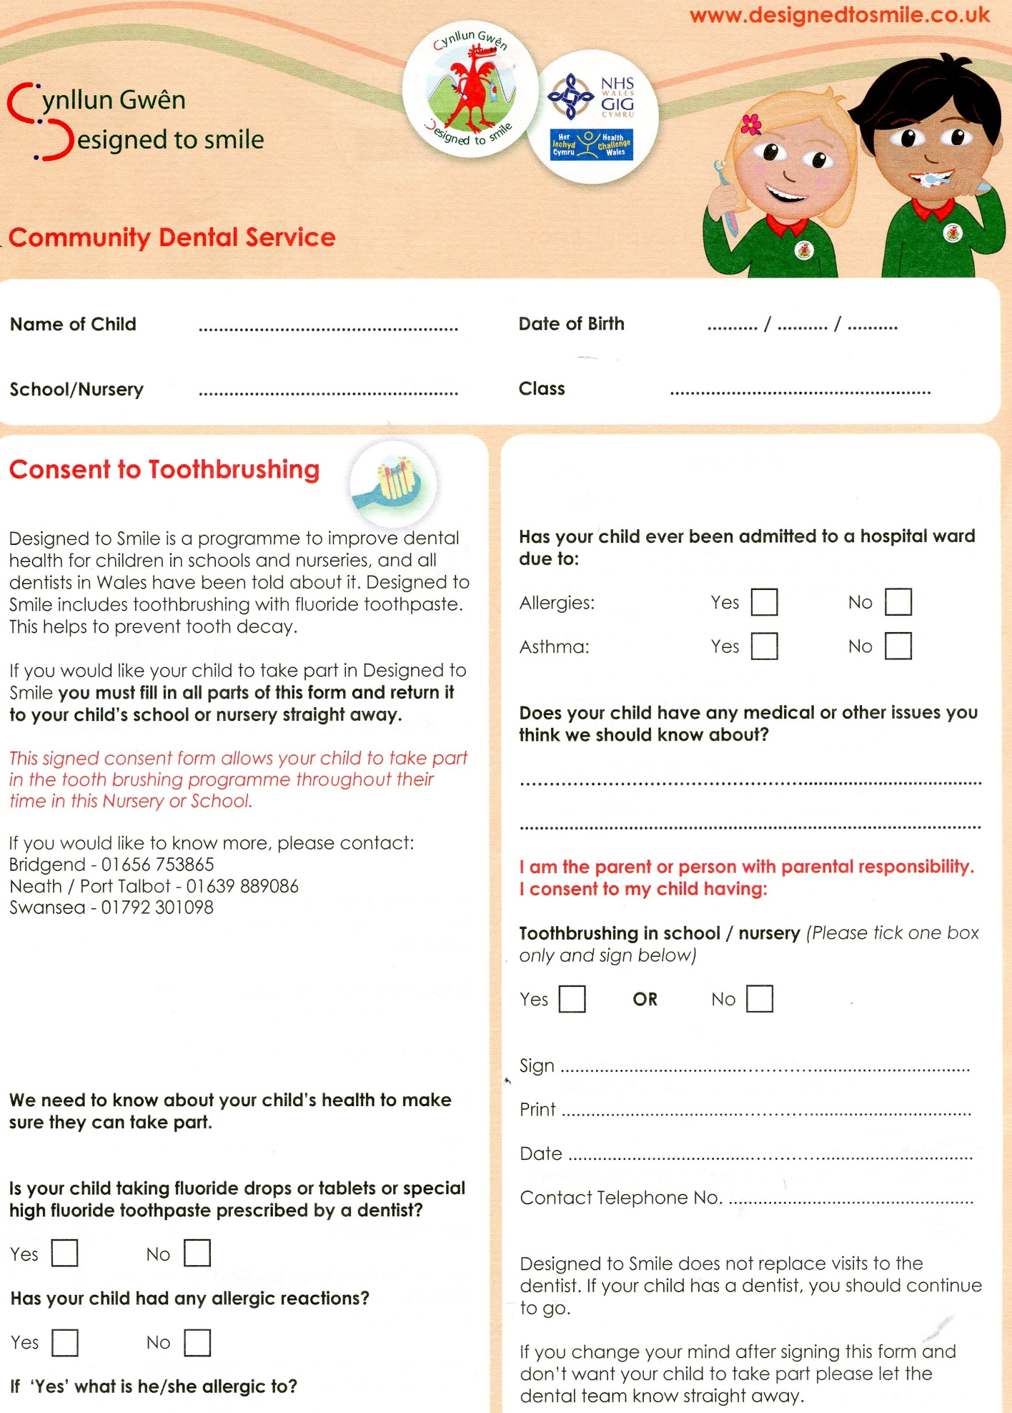
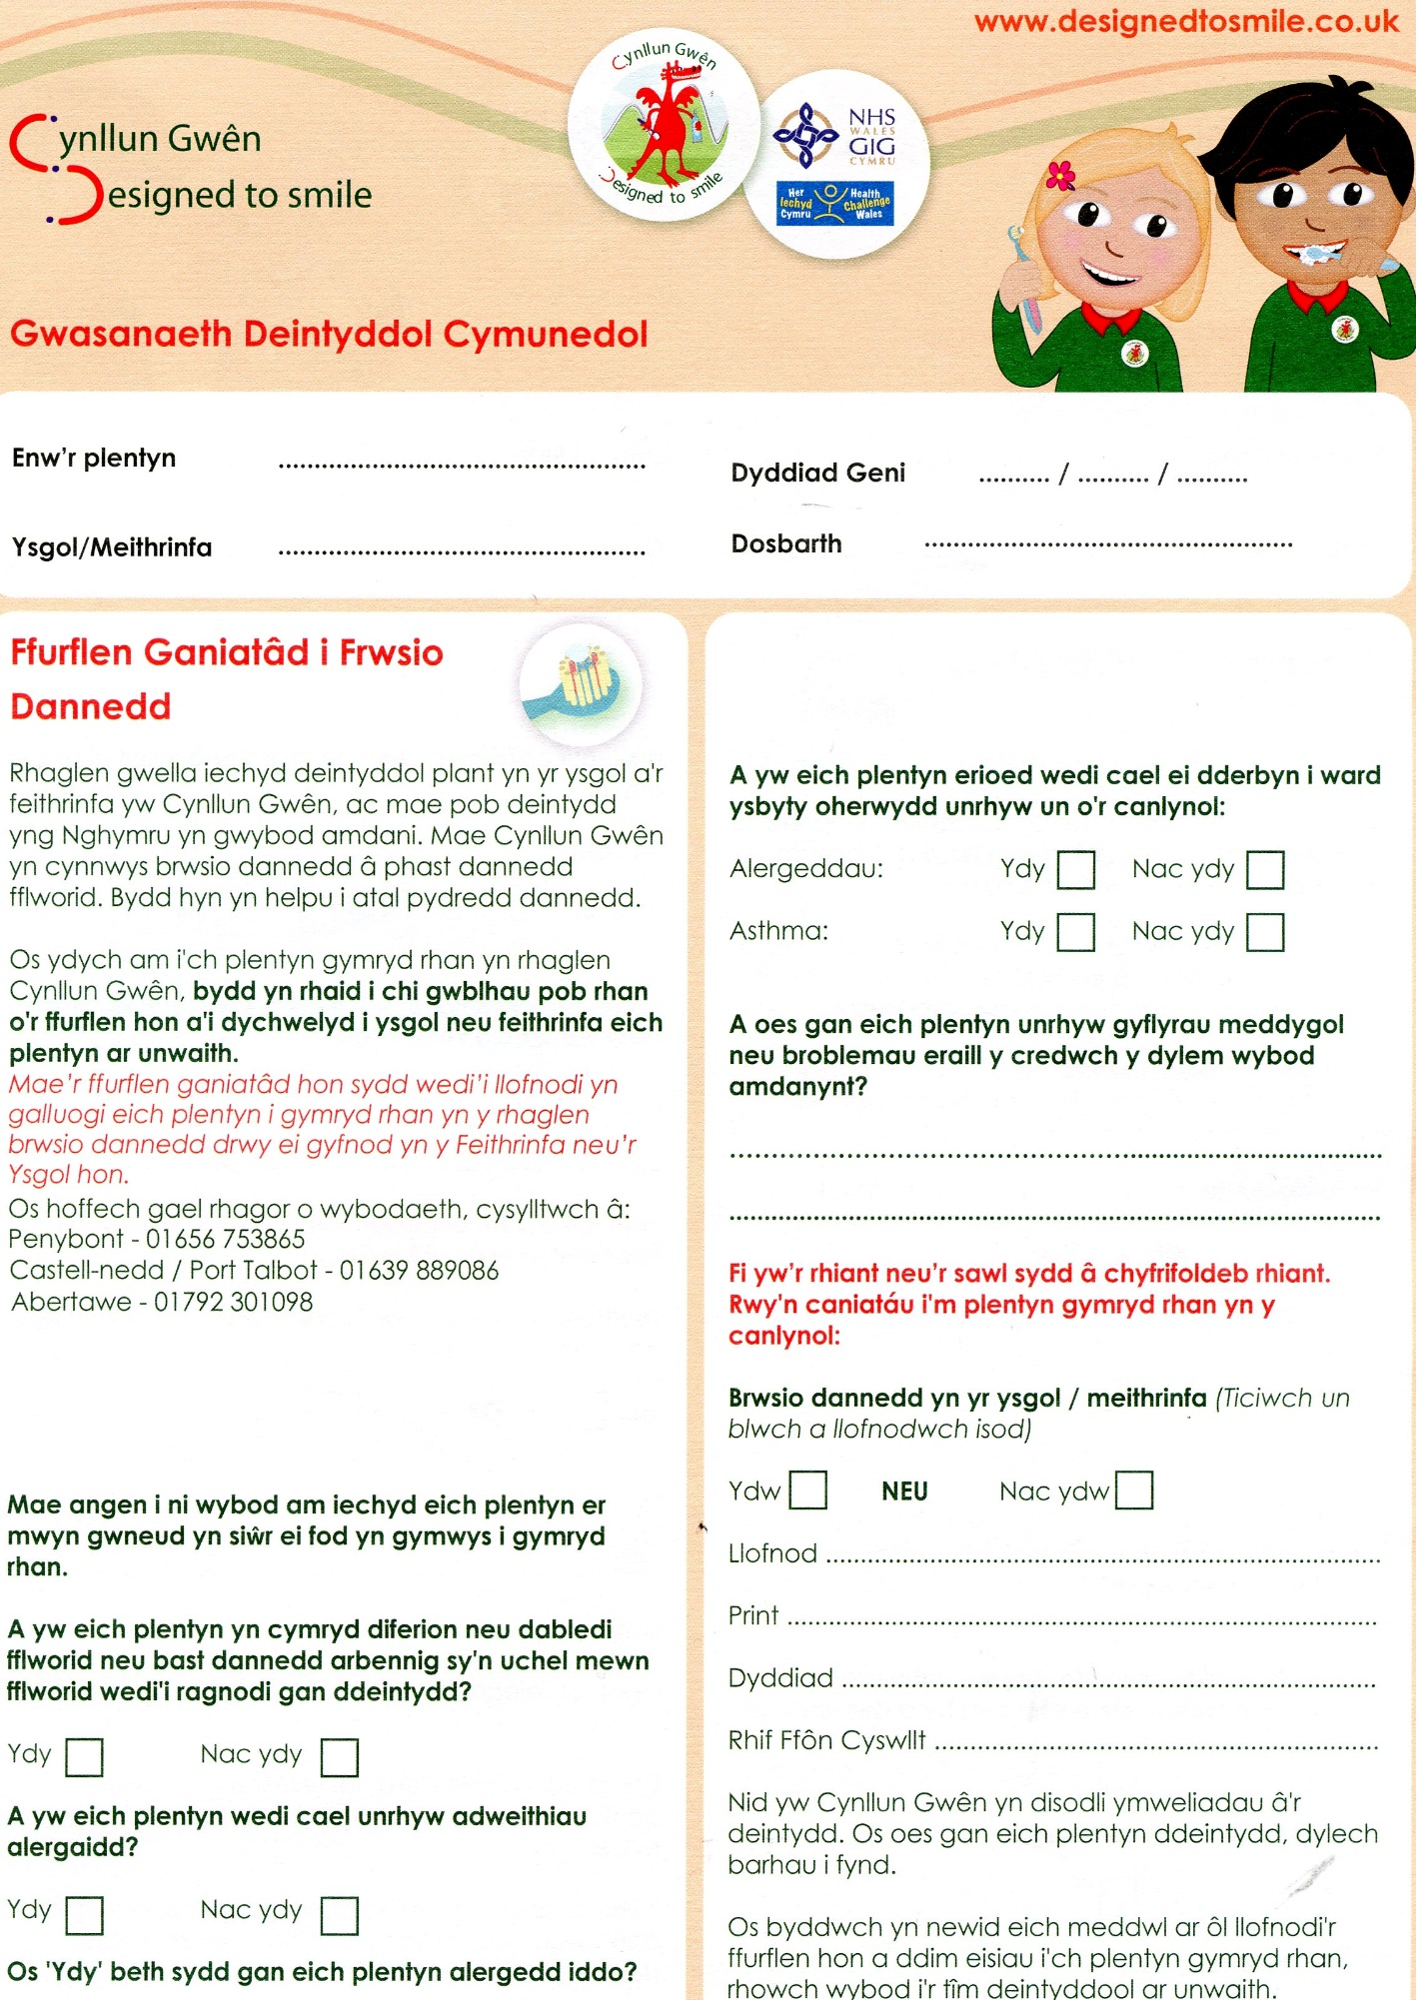

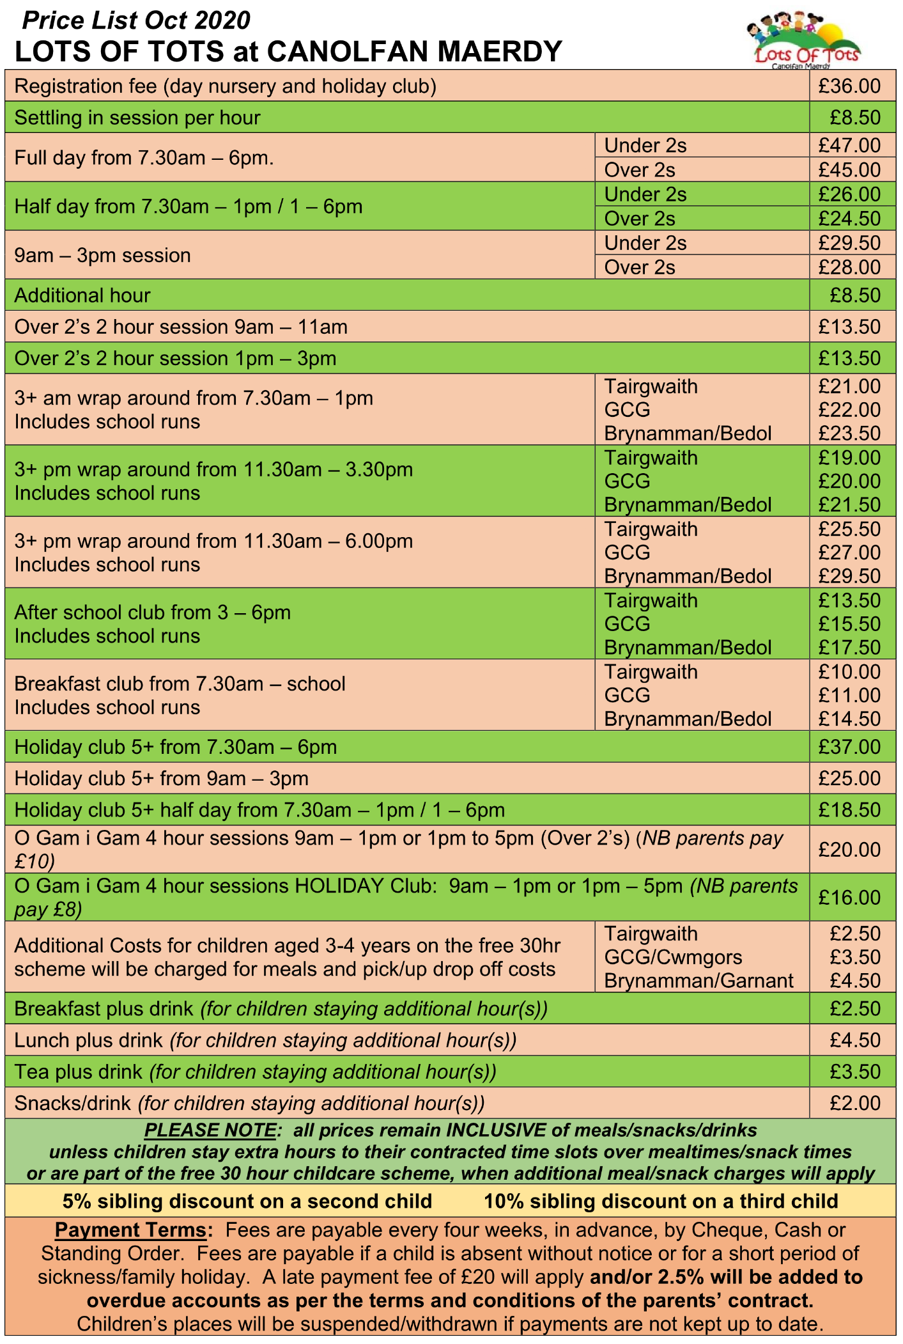

New Road, Tairgwaith, Ammanford,
Neath Port Talbot, SA18 1UP
Tel: 01269 826283 / 07935 401199
Email: lotsoftots@canolfanmaerdy.co.uk
Website: www.canolfanmaerdy.co.uk/lotsoftots

Providing high quality bilingual childcare services for over 25 years.
Our experienced, qualified, dedicated staff
create a secure, caring and happy learning environment
in which every individual child’s needs are catered for.
We accommodate children aged between 0-11 years
and provide fresh, nutritious home cooked meals.

Fully enclosed private outdoor area.
Ample on-site car parking for safe drop off / pick-ups.
New state of the art fingerprint entry security system for your peace of mind

Birth to 3 matters (0-3 years) Foundation phase curriculum (3-5years)

Learning through play

- Story time
- Messy play
- Creative play
- Imaginative play
- Dance and movement
- Songs and nursery rhymes
- Outdoor play
Plus much, much more…..

* All day care * Breakfast Club * After School Club * Holiday Club
* Flying Start * O Gam I Gam * 30 Hour Contract

MONDAY TO FRIDAY 7.30 AM - 6.00 PM
CLOSED BANK HOLIDAYS AND CHRISTMAS

Staff ratios of 1 to 3 (0-2yrs) 1 to 4 (2+yrs) 1 to 8 (3+yrs)

Special needs catered for

CIW regulations, procedures and inspections
Discounts for Siblings

CALL US NOW FOR FURTHER DETAILS
OR TO RESERVE YOUR PLACE!

WEEK 1 | Breakfast | Snack | Lunch | Snack | Tea
MON | Choice of healthy cereals | Selection of seasonal fruit and rice cake | Seasonal vegetable pasta bake.  Natural flavoured yoghurt | Cucumber, soft cheese and tortilla | Pitta / tortilla wraps with seasonal vegetables /salad and choice of filling – ham/tuna/cheese.  Fromage Frais
TUE | Wholemeal toast and milk | Seasonal vegetable sticks, bread sticks and healthy dips | Cottage pie and seasonal vegetables.  Jelly and ice-cream | Selection of seasonal fruit and oat biscuit | Jacket potato and baked beans.  Mini milk
WED | Choice of healthy cereals | Selection of seasonal fruit and crumpets | Fish in parsley sauce with seasonal vegetables and sweet potato wedges.  Bananas and custard | Cherry tomatoes, cheese slices and crackers | Scrambled egg on toast.  Choice of fruit
THURS | Wholemeal toast and milk | Seasonal vegetables and pitta bread | Roast chicken dinner with seasonal vegetables and potato.  Rice pudding and peaches | Selection of seasonal fruit and pancakes | Ploughman’s tea – selection of vegetables / salad and crusty roll and coleslaw.  Milkshake and cookie
FRI | Choice of healthy cereals | Apple, pear and cheese slices | Chilli with boiled rice and corn on the cob.  Raspberry mousse | Seasonal vegetables and Wholemeal toast soldiers | Tomato soup with crusty roll.  Healthy Popcorn

*Choice of healthy cereals – multigrain hoops, rice crispies, shredded wheat, Weetabix
*Selection / seasonal fruit and vegetables – minimum of 2 fresh varieties
*Variety of potato – mash, new potatoes, wedges, chips – sweet potato and potato
*Drinks available with meals and throughout day – water and milk

WEEK 2 | Breakfast | Snack | Lunch | Snack | Tea
MON | Choice of healthy cereals | Selection of seasonal fruit and rice cake | Cheese, onion and potato pie with baked beans.  Natural flavoured yoghurt | Cucumber, soft cheese and tortilla | Pitta / tortilla wraps with seasonal vegetables /salad and choice of filling – ham/tuna/cheese.  Fromage Frais
TUE | Wholemeal toast and milk | Seasonal vegetable sticks, bread sticks and healthy dips | Cawl, crusty bread and cheese.  Jelly and ice-cream | Selection of seasonal fruit and oat biscuit | Jacket potato and baked beans.  Mini milk
WED | Choice of healthy cereals | Selection of seasonal fruit and crumpets | Fish pie with seasonal vegetables.  Bananas and custard | Cherry tomatoes, cheese slices and crackers | Scrambled egg on toast.  Choice of fruit
THURS | Wholemeal toast and milk | Seasonal vegetables and pitta bread | Sausage dinner with seasonal vegetables and potato.  Rice pudding and peaches | Selection of seasonal fruit and pancakes | Ploughman’s tea – selection of vegetables / salad and crusty roll and coleslaw.  Milkshake and cookie
FRI | Choice of healthy cereals | Apple, pear and cheese slices | Spaghetti Bolognaise and garlic bread.  Raspberry mousse | Seasonal vegetables and Wholemeal toast soldiers | Tomato soup with crusty roll.  Healthy Popcorn

*Choice of healthy cereals – multigrain hoops, rice crispies, shredded wheat, Weetabix
*Selection / seasonal fruit and vegetables – minimum of 2 fresh varieties
*Variety of potato – mash, new potatoes, wedges, chips – sweet potato and potato
*Drinks available with meals and throughout day – water and milk

WEEK 3 | Breakfast | Snack | Lunch | Snack | Tea
MON | Choice of healthy cereals | Selection of seasonal fruit and rice cake | Fish fingers, potato and baked beans.  Natural flavoured yoghurt | Cucumber, soft cheese and tortilla | Pitta / tortilla wraps with seasonal vegetables /salad and choice of filling – ham/tuna/cheese.  Fromage Frais
TUE | Wholemeal toast and milk | Seasonal vegetable sticks, bread sticks and healthy dips | Lasagne with seasonal vegetables.  Jelly and ice-cream | Selection of seasonal fruit and oat biscuit | Jacket potato and baked beans.  Mini milk
WED | Choice of healthy cereals | Selection of seasonal fruit and crumpets | Chicken, leek and potato pie with seasonal vegetables.  Bananas and custard | Cherry tomatoes, cheese slices and crackers | Scrambled egg on toast.  Choice of fruit
THURS | Wholemeal toast and milk | Seasonal vegetables and pitta bread | Boiled ham, couscous and seasonal vegetables.  Rice pudding and peaches | Selection of seasonal fruit and pancakes | Ploughman’s tea – selection of vegetables / salad and crusty roll and coleslaw.  Milkshake and cookie
FRI | Choice of healthy cereals | Apple, pear and cheese slices | Fruity chicken curry with boiled rice and naan bread.  Raspberry mousse | Seasonal vegetables and Wholemeal toast soldiers | Tomato soup with crusty roll.  Healthy Popcorn

*Choice of healthy cereals – multigrain hoops, rice crispies, shredded wheat, Weetabix
*Selection / seasonal fruit and vegetables – minimum of 2 fresh varieties
*Variety of potato – mash, new potatoes, wedges, chips – sweet potato and potato
*Drinks available with meals and throughout day – water and milk

Guidance on infection control in schools and other childcare settings
(Currently Under Review) October 2013
Rashes and skin infections | Recommended Period to be Kept Away from School, Nursery or Childminders | Comments
Athlete’s foot | None | Athlete’s foot is not a serious condition. Treatment is recommended
Chickenpox* | Five days from the onset of rash | See: Vulnerable children and female staff – pregnancy
Cold sores,  (Herpes simplex) | None | Avoid kissing and contact with the sores.  Cold sores are generally mild and self-limiting
Impetigo | Until lesions are crusted and healed, or 48 hours after commencing antibiotic treatment | Antibiotic treatment speeds healing and reduces the infectious period
Measles* | Four days from onset of rash | Preventable by vaccination (MMR x 2).  See: Vulnerable children and female staff – pregnancy
Molluscum contagiosum | None | A self-limiting condition
Ringworm | Exclusion not usually required | Treatment is required
Roseola (infantum) | None | None
Scabies | Child can return after first treatment | Household and close contacts require treatment
Scarlet fever* | Child can return 24 hours after commencing appropriate antibiotic treatment | Antibiotic treatment recommended for the affected child
Slapped cheek (fifth disease or parvovirus B19) | None | See: Vulnerable children and female staff – pregnancy
Shingles | Exclude only if rash is weeping and cannot be covered | Can cause chickenpox in those who are not immune i.e. have not had chickenpox. It is spread by very close contact and touch. If further information is required, contact the Duty Room. SEE: Vulnerable Children and Female Staff – Pregnancy
Warts and verrucae | None | Verrucae should be covered in swimming pools, gymnasiums and changing rooms
Prevent the spread of infections by ensuring: routine immunisation, high standards of personal hygiene and practice, particularly handwashing, and maintaining a clean environment.
Please contact the Public Health Agency Health Protection Duty Room (Duty Room) on 028 9055 3994/7 or visit www.publichealth.hscni.net or www.gov.uk/government/organisations/Public-health-england if you would like any further advice or information, including the latest guidance.

Diarrhoea and Vomiting Illness | Recommended Period to be Kept Away from School, Nursery or Childminders | Comments
Diarrhoea and/or vomiting | 48 hours from last episode of diarrhoea or vomiting
E. coli O157  VTEC*  Typhoid* [and paratyphoid*]  (enteric fever)  Shigella*  (dysentery) | Should be excluded for 48 hours from the last episode of diarrhoea  Further exclusion may be required for some children until they are no longer excreting | Further exclusion may be required for young children under five and those who have difficulty in adhering to hygiene practices  This guidance may also apply to some contacts who may require microbiological clearance  Please consult the Duty Room for further advice
Cryptosporidiosis* | Exclude for 48 hours from the last episode of diarrhoea | Exclusion from swimming is advisable for two weeks after the diarrhoea has settled

Respiratory Infections | Recommended Period to be Kept Away from School, Nursery or Childminders | Comments
Flu (influenza) | Until recovered | See: Vulnerable Children
Tuberculosis | Always contact the Duty Room | Requires prolonged close contact to spread
Whooping Cough (Pertussis) | Five days from commencing antibiotic treatment or 21 days from onset of illness I no antibiotic treatment | Preventable by vaccination. After treatment, non-infectious coughing may continue for many weeks. The Duty Room will organise any contact tracing necessary

Other Infections | Recommended Period to be Kept Away from School, Nursery or Childminders | Comments
Conjunctivitis | None | If an outbreak/cluster occurs, consult the Duty Room
Diptheria* | Exclusion essential. Please contact the Duty Room
Glandular Fever | None
Head Lice | None | Treatment is recommended only in cases where live lice have been seen
Hepatitis A* | Exclude until seven days after onset of jaundice (or seven days after symptom onset if no jaundice) | In an outbreak of hepatitis A, the Duty Room will advise on control measures
Hepatitis B*, C, HIV/AIDS | None | Hepatitis B and C and HIV are bloodborne viruses that are not infectious through casual contact. For cleaning of body fluid spills, SEE: Good Hygiene Practice
Meningococcal Meningitis*/Septicaemia* | Until recovered | Meningitis C is preventable by vaccination. There is no reason to exclude siblings or other close contacts of a case. The Duty Room will advise on any action needed.
Meningitis* due to other bacteria | Until recovered | Hib and pneumococcal meningitis are preventable by vaccination. There is no reason to exclude siblings or other close contacts of a case. The Duty Room will give advice on any action needed.
Meningitis Viral* | None | Milder illness. There is no reason to exclude siblings and other close contacts of a case. Contact tracing is not required
MRSA* | None | Good hygiene, in particular handwashing and environmental cleaning, are important to minimise any danger of spread. If further information is required, contact the Duty Room
Mumps* | Exclude child for five days after onset of swelling | Preventable by vaccination (MMR x 2 doses)
Threadworms | None | Treatment is recommended for the child and household contacts
Tonsillitis | None | There are many causes, but most cases are due to viruses and do not need an antibiotic

* denotes a notifiable disease. It is a statutory requirement that doctors report a notifiable disease to the Director of Public Health via the Duty Room.
Outbreaks: If a school, nursery or childminder suspects an outbreak of infectious disease, they should inform the Duty Room.
Good hygiene practice
Handwashing is one of the most important ways of controlling the spread of infections, especially those that cause diarrhoea and vomiting, and respiratory disease. The recommended method is the use of liquid soap, warm water and paper towels. Always wash hands after using the toilet, before eating or handling food, and after handling animals. Cover all cuts and abrasions with waterproof dressings.

Coughing and sneezing easily spread infections. Children and adults should be encouraged to cover their mouth and nose with a tissue. Wash hands after using or disposing of tissues. Spitting should be discouraged.

Personal protective equipment (PPE). Disposable non-powdered vinyl or latex-free CE-marked gloves and disposable plastic aprons must be worn where there is a risk of splashing or contamination with blood/body fluids (for example, nappy or pad changing). Goggles should also be available for use if there is a risk of splashing to the face. Correct PPE should be used when handling cleaning chemicals.

Cleaning of the environment, including toys and equipment, should be frequent, thorough and follow national guidance. For example, use colour-coded equipment, follow Control of Substances Hazardous to Health (COSHH) regulations and correct decontamination of cleaning equipment. Monitor cleaning contracts and ensure cleaners are appropriately trained with access to PPE.

Cleaning of blood and body fluid spillages. All spillages of blood, faeces, saliva, vomit, nasal and eye discharges should be cleaned up immediately (always wear PPE). When spillages occur, clean using a product that combines both a detergent and a disinfectant. Use as per manufacturer’s instructions and ensure it is effective against bacteria and viruses and suitable for use on the affected surface. Never use mops for cleaning up blood and body fluid spillages – use disposable paper towels and discard clinical waste as described below. A spillage kit should be available for blood spills.

Laundry should be dealt with in a separate dedicated facility. Soiled linen should be washed separately at the hottest wash the fabric will tolerate. Wear PPE when handling soiled linen. Children’s soiled clothing should be bagged to go home, never rinsed by hand.

Clinical waste. Always segregate domestic and clinical waste, in accordance with local policy. Gloves, aprons and soiled dressings should be stored in correct clinical waste bags in foot-operated bins. All clinical waste must be removed by a registered waste contractor. All clinical waste bags should be less than two-thirds full and stored in a dedicated, secure area while awaiting collection.
Sharps, eg needles, should be discarded straight into a sharps bin conforming to BS 7320 and UN 3291 standards. Sharps bins must be kept off the floor (preferably wall-mounted) and out of reach of children.

Sharps injuries and bites
If skin is broken as a result of a used needle injury or bite, encourage the wound to bleed/wash thoroughly using soap and water. Contact GP or occupational health or go to A&E immediately. Ensure local policy is in place for staff to follow. Contact the Duty Room for advice, if unsure.

Animals
Animals may carry infections, so wash hands after handling animals. Health and Safety Executive for Northern Ireland (HSENI) guidelines for protecting the health and safety of children should be followed.

Animals in school (permanent or visiting). Ensure animals’ living quarters are kept clean and away from food areas. Waste should be disposed of regularly, and litter boxes not accessible to children. Children should not play with animals unsupervised. Veterinary advice should be sought on animal welfare and animal health issues and the suitability of the animal as a pet. Reptiles are not suitable as pets in schools and nurseries, as all species carry salmonella.

Visits to farms. For more information see www.hseni.gov.uk/hseni_information_sheet_no_1_11.pdf

Vulnerable children
Some medical conditions make children vulnerable to infections that would rarely be serious in most children, these include those being treated for leukaemia or other cancers, on high doses of steroids and with conditions that seriously reduce immunity. Schools and nurseries and childminders will normally have been made aware of such children. These children are particularly vulnerable to chickenpox or measles and, if exposed to either of these, the parent/carer should be informed promptly and further medical advice sought. It may be advisable for these children to have additional immunisations, for example pneumococcal and influenza.

Pregnancy
If a pregnant woman develops a rash or is in direct contact with someone with a potentially infectious rash, this should be investigated by a doctor. The greatest risk to pregnant women from such infections comes from their own child/children, rather than the workplace.

Chickenpox can affect the pregnancy if a woman has not already had the infection. Report exposure to midwife and GP at any stage of exposure. The GP and antenatal carer will arrange a blood test to check for immunity. Shingles is caused by the same virus as chickenpox, so anyone who has not had chickenpox is potentially vulnerable to the infection if they have close contact with a case of shingles.

German measles (rubella). If a pregnant woman comes into contact with German measles she should inform her GP and antenatal carer immediately to ensure investigation. The infection may affect the developing baby if the woman is not immune and is exposed in early pregnancy.

Slapped cheek disease (fifth disease or parvovirus B19) can occasionally affect an unborn child. If exposed early in pregnancy (before 20 weeks), inform whoever is giving antenatal care as this must be investigated promptly.

Measles during pregnancy can result in early delivery or even loss of the baby. If a pregnant woman is exposed she should immediately inform whoever is giving antenatal care to ensure investigation.

Immunisations
Immunisation status should always be checked at school entry and at the time of any vaccination. Parents should be encouraged to have their child immunised and any immunisation missed or further catch-up doses organised through the child’s GP.

For the most up-to-date immunisation advice visit www.publichealth.hscni.net or the school health service can advise on the latest national immunisation schedule.

Routine childhood immunisation programme
When to immunise | Diseases vaccine protects against | How it is given
2 months old | Diphtheria, tetanus, pertussis (whooping cough), polio and Hib  Pneumococcal infection  Rotavirus | One injection  One injection  Orally
3 months old | Diphtheria, tetanus, pertussis, polio and Hib  Meningitis C  Rotavirus | One injection  One injection  Orally
4 months old | Diphtheria, tetanus, pertussis, polio and Hib  Pneumococcal infection | One injection  One injection
Just after the first birthday | Measles, mumps and rubella  Pneumococcal infection  Hib and meningitis C | One injection  One injection  One injection
3 years and 4 months old | Diphtheria, tetanus, pertussis and polio  Measles, mumps and rubella | One injection  One injection
Girls 12 to 13 years old | Cervical cancer caused by human papillomavirus types 16 and 18 | Three injections over six months
14 to 18 years old | Tetanus, diphtheria and polio  Meningitis C | One injection  One injection

This is the UK Universal Immunisation Schedule as of October 2013. Children who present with certain risk factors may require additional immunisations.

Original material was produced by the Health Protection Agency and this version adapted by the Public Health Agency, 12-22 Linenhall Street, Belfast, BT2 8BS.
Tel: 028 9032 1313.
www.publichealth.hscni.net

Information produced with the assistance of the Royal College of Paediatrics and Child Health.

LIST OF LOTS OF TOTS POLICIES AND PROCEDURES
Child protection / Safeguarding
- Child protection / Safeguarding

Medical support
- Accidents & First Aid
- Medication & Asthma
- Immunisation
- Sickness & Illness
- Infection control
- Allergies & Allergic reactions
- Sun Care
- Head lice Policy

Equality & Inclusion
10) Inclusion & Equality
11) Dealing with discriminatory behaviour
12) Behaviour management
13) Biting Policy
14) Early learning Opportunities Statement
15) Special Educational Needs
16) Settling in
17) Supporting Transitions
18) Separated family
19) Intimate care
20) Nappy Changing
21) Outdoor Play
22) Babies and Toddlers
23) Bereavement
24) Children’s rights & Participation
25) Equal Opportunities
26) Key worker
27) Welsh language policy

Food & Nutrition
28) Nutrition & Mealtimes
29) Healthy Eating
30) Food hygiene and safety

Partnerships with parents
31) Parents as carers & partners
32) Complaints & Concerns
33) Access and Storage of information
34) Late Collection & Non Collection
35) Admissions
36) Arrivals & Departures
37) Camera & recording device use
Staff
38) Personnel
39) Staff development & Training
40) Confidentiality
41) Staff discipline Policy
42) Special considerations for employees
43) Safe recruitment of Staff
44) Supervision of Staff
45) Mobile phone & Social networking
46) Staff working with their own children / close relation
47) Students
48) Volunteers
49) Whistleblowing
50) Absence management
51) Return to Work
52) Dealing with Difficult Parents
53) Maternity / Paternity / Adoption Policy
54) Lone Worker Policy
55) Retirement Policy
56) Request for variation in working hours Policy
57) Staff Induction Policy

General Operations & Health & Safety
58) Staff Ratios
59) Statement of purpose
60) Health & Safety
61) Fire Safety
62) Safety checks
63) First Aid
64) Manual Handling
65) Health and Safety in the office
66) Stress Management
67) Healthy Workplace
68) Environment
69) Visits & Outings
70) Lost child procedure from Nursery
71) Lost child procedure from Outings
72) Smoking Policy
73) Equipment & resources
74) Critical Incident
75) Adverse weather
76) Supervision of children
77) Supervision of Visitors
78) School / home drop off / pick up Policy
79) Waste management Policy
80) Bomb Threat / Terrorism attack policy
81) Emergency Evacuation procedure
82) Operational Plan

Admissions / Settling In
We recognise the need for parents and children to view the nursery before confirming a place. We will try and be as flexible as possible, however, meal times are best avoided to allow children to enjoy their meal in a relaxed setting.

Please feel free to arrange a mutually convenient time to view and ask any questions that you may have.

Casual callers at the nursery will be asked for identification and must sign the visitor’s book. If it is convenient, they may view the nursery, if not, then they will be asked to return with an appointment.

Mums and Dads to be
Are very welcome to view the nursery before and after baby is born. Initial registration made before the birth will need to be confirmed once baby is born in order to secure a place.

Registration
Once you have decided to attend the nursery, you will be given the necessary registration documents. These will need to be returned along with your registration fee prior to your child/ren’s first day. Your child’s place will then be confirmed. All records are confidential.

Waiting List
A waiting list may be in operation. Should you wish to be contacted as soon as a space is available at nursery, please complete an initial waiting list application form, which is available from the Nursery Manager and the Canolfan Maerdy website (www.canolfanmaerdy.co.uk) Do not include a registration fee at this time. We can then try to match up your requirements when a space is available. Please keep contact with the nursery should you wish in the meantime.

Settling In
Once a place has been confirmed for your child, you will be invited to attend trial sessions of 1 hour slots per day, at a cost of £5 per session; these will need to be booked in advance to ensure sufficient staffing. The number of sessions can be catered to suit each individual child – you are welcome to stay with your child to help them settle into the nursery if you so wish or you may prefer to wait in our café.

Procedure to follow in the event of a child not being collected
In the event of a child not being collected at the end of their session, or after the nursery has closed, the following procedures will take place:

1) Telephone parent/carer or one of alternative contacts from list provided. If they cannot be contacted, inform Nursery Manager, Chief Executive Officer and Chair of the Board of Trustees.

2) The nursery will not release the child to an unauthorised person, even if the collection is late, unless an authorised person telephones to state that because of an emergency, a different person will be collecting.

3) Full details of the person collecting, along with a password will be required in order for the unauthorised carer to collect.

4) If we are unable to contact the parent/carers or alternative contacts, social services will be informed and their advice will be followed.
Behaviour Guidelines
Acceptable behaviour is learned from those around us. It is reinforced by rewards such as praise and encouragement and by consistent attitudes of staff and parents. In the nursery, we expect children to be working towards the following rules of behaviour at a level that is appropriate to their individual levels of development and ages. By working together, we hope that the children in our care will grow up to be responsible, caring and confident, with respect for themselves and others.

Children should:

- Show consideration and respect for other children and staff members,
- Value and respect nursery property and the property of children in the nursery,
- Listen to and follow staff members’ requests,
- Show appropriate manners at mealtimes.

Children must not:

- Threaten or intimidate other children
- Deliberately hurt other children or staff members, eg by hitting, pinching, kicking or biting,
- Discriminate against other children, eg on the base of race, nationality or religion,
- Cause distress to other children by name-calling, exclusion or other hurtful actions,
- Use swear words or other inappropriate language.

Behaviour Management Policy
We believe that children and adults flourish best in an ordered environment in which everyone knows what is expected of them and children are free to develop their play and learning without fear of being hurt or hindered by anyone else. We aim to work towards a situation in which children can develop self-discipline and self-esteem in an atmosphere of mutual respect and encouragement.

In order to achieve this:
- Rules governing the conduct of the nursery and the behaviour of the children will be discussed and agreed within the nursery and explained to all newcomers, both adults and children.
- All adults in the nursery will ensure that rules are applied consistently so that children can have the security of knowing what to expect and can build up useful habits of behaviour.
- All adults in the nursery will be a positive role model for the children with regard to friendliness, care and courtesy.
- Adults in the nursery will praise and endorse desirable behaviour such as kindness and willingness to share.
- We will take positive steps to avoid a situation in which children receive adult attention only in return for undesirable behaviour.

When children behave in unacceptable ways:
- Physical punishment, such as smacking or shaking, will neither be used nor threatened.
- Children will never be sent out of the rooms by themselves.
- Techniques intended to single out and humiliate individual children such as the ‘naughty chair’ will not be used.
- Children who misbehave will be given one-to-one adult support in seeing what was wrong and working towards a better pattern.
- Where appropriate, this might be achieved by a period of ‘time out’ with an adult.
- In cases of serious misbehaviour, such as racial or other abuse, the unacceptability of the behaviour and attitudes will be made clear immediately, but by means of explanations rather than personal blame.
- In any case of misbehaviour, it will always be made clear to the child or children in question that it is the behaviour and not the child that is unwelcome.
- Adults will not shout, or raise their voices in a threatening way.
- Adults in the nursery will make themselves aware of, and respect, a range of cultural expectations regarding interactions between people.
- Any behaviour problems will be handled in a developmentally appropriate fashion respecting individual children’s level of understanding and maturity.
- Recurring problems will be tackled by the whole nursery, in partnership with the child’s parents, using objective observation records to establish an understanding of the cause.
- Adults will be aware that some kinds of behaviour may arise from a child’s special needs or particular transition within the nursery or at home. (See Special Needs Policy and Transitions Policy.)

Anti-bullying
Bullying comes in many forms – physical, verbal, silent and in isolation, etc. Our nursery believes that all children and individuals have the right to come to nursery without fear of being bullied. Any act of bullying will be investigated by the manager and deal with immediately.

In General
All children, parents, carers and members of staff attending the nursery are expected to follow simple rules concerning acceptable behaviour:
- Be kind to each other
- Take care of each other by keeping the safety rules
- Take care of property and equipment
- Listen to and respect each other

Conclusion
This Behaviour Policy aims to protect children by endorsing and reinforcing good behaviour while gently but firmly showing the child that certain behaviour is unacceptable and will not be tolerated.

Key Worker Policy for Parents
Our nursery believes that the implementation of an effective key worker system is essential to the overall development of each child.

We respect that parents and families are the main carers in their child’s life and through good communication, positively promote trusting relationships with them.

We strongly believe that caring adults count more than resources and equipment.

Our team is committed to ensure consistent staff groups minimise the number of carers, thereby enabling them to form close authentic relationships, ensuring improved wellbeing for their key children.

We aim for key staff to be the first point of contact when a child is settling in: time taken to share information with parents and get to know the important needs a family may have. The key workers should be available to greet and give feedback on a regular basis. A written report for the under 2s is completed after each session and shared with the parent. Over 2’s receive verbal feedback daily, written information can be provided on request; your attention is drawn to the over 2’s information board (situated in the over 2’s room) which outlines the daily activities and the parent notice board. (Situated in the main reception area.)

Staff build on their knowledge of the child through information from home, spending time one-to-one and careful observations in the setting. Together these enable the key person to provide favourite activities and adapt their response to individual children. Staff collate relevant evidence for a child[s development record that is shared with the parent.

When the child is ready to move into another section, the key worker ensures that the transition period is gradual and in line with the needs of the child and follows the transition policy.

Key staff keep parents up to date with what is going on in the nursery and in particular events in their child’s section.

All staff understand the importance of children’s and families rights for confidentiality and respect that right by adhering to the policy in place.

Transitions Policy
Starting nursery, moving from one room to another, changing settings or starting school is an exciting time for children, but can also be a challenging and anxious time for both children and their parent/carers. We are committed to putting the needs of the child first whilst working with each other, parents/carers and other professionals to make transitions as smooth as possible for all concerned.

Starting Nursery
We try to make the transition from home to nursery as stress free as possible by following our Settling in Policy:

- Settling in visits will be arranged, these are short visits to the nursery and a time for children and parents/carers to meet staff members and the key person. This allows the child to familiarise themselves with the environment.

- The number of settling in visits and length of time is flexible depending on the individual needs of that child.

- We ensure that parents/carers are given plenty of information about all aspects of the nursery before their child starts.

- Parents/carers have opportunities when dropping off and collecting their child to talk with their key person about their day, activities their child has taken part in, what they’ve eaten and if they’ve slept etc. Under 2’s will be given a handover sheet containing these details. Over 2’s have a specific parent board containing these details and handover is verbal.

- It is clear to parents/carers from the start that they are welcome and supported at the nursery for as long as it takes to settle their child, and subsequently during their child’s time at nursery.

- Each child is different so we work with parents/carers to find out the best way to ease their child into nursery life.

- The nursery has a daily routine that we feel is very important to the children as it allows them to know what is happening next, when they will be collected etc.

- Parents/carers are welcome to telephone throughout the day to see how their child is.

Transition from Under 2’s to Over 2’s
Although children moving from our Under 2’s room to our Over 2’s room have usually been with us for some time, we still see this as an important transition for them and feel that it is important that this is planned and carried out in a way that meets the needs of each individual child

- Children normally transfer to the Over 2’s room after their second birthday. Prior to this children will visit the Over 2’s room with their key person from the Under 2’s room. They will stay with them, introducing them primarily to their new key person and then other staff members. They will also show them the nappy changing area, toilets, new peg etc.

- The child’s current key person will share relevant information with the new key person such as nap times, allergies and medical needs. They will also pass on the child’s ‘Watch me grow’ along with their developmental records at time of transfer.

- A Transition sheet will be passed on from the child’s key person containing information such as sleep times, allergies and dietary requirements. This will help all staff members in the Over 2’s room in meeting the needs of the child.

- The child will continue visits into the Over 2’s room with less support from their key person and for longer periods of time, these will be determined according to each individual child.

- The child’s new key person will introduce themselves to the child’s parent/carer and give them any information that they may require on the Over 2’s room such as daily routine.

Transition to School / another Setting
The move from nursery to school is a big step for both children and their parents/ carers. We have close links and good communication with the local schools and sometimes children will move to a new setting due to relocation etc. In this situation we will ensure that the child’s Watch me grow and developmental records at the time of transition are fully up to date and ready to pass on to the parent / guardian who can then pass on to the school / next setting if they so wish. If needed, and with the parents/carers permission we are always available to talk with the school / new setting and share any information that may be deemed useful.

By ensuring that all of things are fully in place we hope to make all transitions for children and their parents/carers as stress free as possible.

Special Needs Policy
There are many definitions of special needs that are appropriate for different purposes. Many children may be assessed as having a special need at some time in their school life. This assessment for the majority of children is temporary and may only apply to their behavioural or educational needs within a school setting. Children who need extra support within the classroom may have no special need within a play setting. Some children however may require specialist treatment, facilities or care whilst at Lots Of Tots that is above and beyond the usual provision for most children.

- Lots of Tots aims to provide a welcoming and supportive environment for all children, staff and parents. They will all be treated with dignity and respect. Lots of Tots supports integration and the treatment of all children and adults as individuals, wherever this is possible.

- The childcare facility will have regard to Wales Code of Practice (2002) and the Disability Discrimination Act (1995) on the identification, assessment and education of children with special educational needs.

- Staff, helpers and parents/carers and visitors with special needs will be welcomed and supported by the nursery, in keeping with the Equal Opportunities Policy, with the needs of the children being of paramount importance at all times.

- Children with special needs, like all other children, will be admitted after full consultation with parent/carers, nursery staff, referral scheme co-ordinators, and any other relevant agency workers involved. Consideration will be given to all disabilities; all meetings, recommendation and decisions will be documented.

- As far as possible children with special needs will be included in all activities, including outings. If necessary, equipment and activities will be adapted to meet the needs of the child.

- Records of the children’s progress will be maintained and reviewed regularly.

- Parental permission will be obtained, on admission, before records are released to other agencies.

- The childcare facility will request additional assistance, via the Special Needs Referral Scheme, for one to one help and possible assistance with travel, when necessary and where available.

- Full co-operation will be given to all appropriate agencies, i.e. Health Visitor, medical staff, therapists, social workers, psychologists, portage workers etc. in order to meet the needs of the child.

- The nursery staff whenever possible will attend appropriate special needs training provided by the most relevant agency.

- All the childcare facilities health and safety procedures will be reviewed with the admission of the child with special needs.
COMPLAINTS PROCEDURE
A Parent’s Guide

We want you and your child to be happy with the service we provide. We record and fully investigate any complaints received. You will have a response to your complaint within a maximum of 35 days.

Most issues can be resolved by speaking to your child’s keyworker in the first instance.

Are you satisfied? Yes

No → If you are not happy with the outcome, then please speak to the Nursery Management

Are you satisfied? Yes

No → If you are not happy with the outcome, then please speak to the Chair of Trustees
at Canolfan Maerdy, Tel: 01269 826893, Email: ljp@canolfanmaerdy.co.uk

Are you satisfied? Yes

No → Our nursery is registered with CIW who are independent inspectors of quality. They can be contacted
directly with a complaint of a regulatory nature about our service at:
Care Inspectorate Wales,
South West Regional Office, Government Buildings, Picton Terrace, Carmarthenshire. SA31 3BT
Tel: 0300 790 0126

